**Chapter 5 Exercises**

5.1 Reset Drive to Factory Default 2

5.1.1 Default the drive using the Intelligent Operator Panel (IOP). 3

5.2 Control the drive locally with the IOP 5

5.2.1 Place the drive in ‘local” control and operate. 6

5.3 Add a G120 to the Project and configure. 7

5.3.1 Add a G120 Drive to the Project and Configure. 8

1) Add a G120 drive to the project and configure. 8

2) Configure the drive Profinet name, telegrams and IO addresses. 9

3) Download the configuration to the PLC. 11

5.4 Add a drive as a Speed Technology Object and control it from the PLC 12

5.4.1 Configure Drive Motion Object 14

1) Reconfigure drive as motion object by using the motion control wizard 14

2) Enter motor data **Error! Bookmark not defined.**

3) Enter or select motor plate data **Error! Bookmark not defined.**

4) Download new configuration to drive 16

5) Add a Speed Axis Technology Object to the 1500. 18

5.4.3 Modify the program and add PLCopen blocks to control the TO 20

1) Modify the program and add PLCopen blocks. 20

* 1. **Reset Drive to Factory Default**

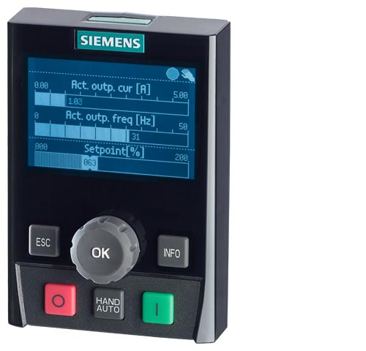

5.1 Reset Drive to Factory Default

**Description**

Default the drive to factory preset condition

**Objectives**

* Reset to Factory Default to establish a defined output state. In the factory default, the inverter is already functional and can be controlled via PROFINET.

**Prerequisites**

The following prerequisites must be completed before this exercise is started:

* Chapter 4 exercises have been completed, OR the Chapter 5 Seed Project archive has been opened for editing

5.1.1 Default the drive using the Intelligent Operator Panel (IOP).

|  |
| --- |
| 1. Make sure the IOP is displaying the “home” screen. Press the ESC button repeatedly until the display shows the three options “Wizards”, “Control”, and “Menu”.      1. Using the OK wheel, rotate the wheel to highlight “Menu”, then press the button in to access the Menu. 2. Rotate the OK wheel to highlight the menu item “*Extras”.      1. Push the wheel in to select the “*Extras” menu item. 2. From the “*Extras” sub-menu, use the OK wheel to select “Parameter settings”. 3. From the “Parameter settings” sub menu, select “Drive Factory Reset”.      1. From the follow-on screen, select “Yes” to answer the “Reset the drive to factory settings?” question, then push in the OK button.      1. The reset procedure will begin.      1. After short delay, the process will complete.      1. Press the OK button to acknowledge the message. The drive parameters are now reset to their factory values.   *This completes Exercise 5.1.* |

**5.2 Control the Drive locally using the IOP**

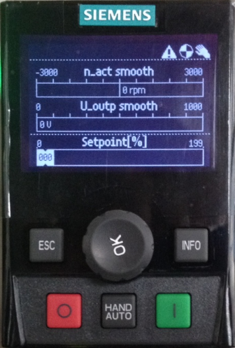

5.2 Control the drive locally with the IOP

**Description**

Use the Intelligent Operator Panel to place the drive in local control for testing.

**Objectives**

* Operate the drive locally using the IOP.

**Prerequisites**

The following prerequisites must be completed before this exercise is started:

* Chapter 5.1 exercise has been completed.
  + 1. Place the drive in ‘local” control and operate.

|  |
| --- |
| 1. Press the “Hand/Auto” button on the drive ONCE. Allow the drive to respond! The IOP will show the drive is in local control. Note the “Hand” icon.      1. Press the green “I” button to start the drive. 2. Use the “OK” wheel to adjust the setpoint speed. 3. Press the red “O” button to stop the drive. 4. Press the “Hand/Auto” button to return the drive to remote control from the network. Note the “Network” icon.     *This completes Exercise 5.2.* |

* 1. **Add a G120 to the Project and Configure**

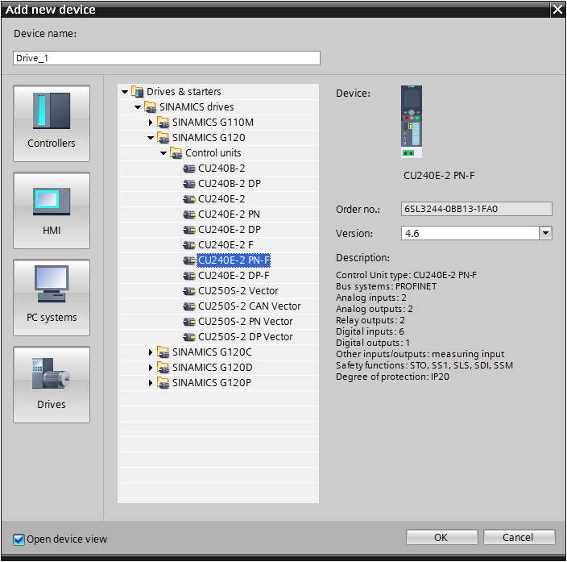

5.3 Add a G120 to the Project and configure.

**Description**

Profinet provides a standardized interface for transferring predominantly binary process data between an “interface module” in the (central) programmable controller and the field devices. This “interface module” is called the IO controller and the field devices are the IO devices

In this exercise, the S7 1500 simulator hardware will be have a SINAMICS G120 drive added to the configuration as an IO device.

**Objectives**

Upon completion of this exercise, the student shall be able to:

* Add a SINAMICS G120 drive to the Profinet network.
* Configure the drive telegrams and IO addresses.

**Prerequisites**

The following prerequisites must be completed before this exercise is started:

* Chapter 4 exercises have been completed.
  + 1. Add a G120 Drive to the Project and Configure.

|  |
| --- |
| 1. Add a G120 drive to the project and configure. 2. In the Project tree, double click on the “Add new device” object to open the Add new device dialog. 3. Select “Drives” from the dialog. 4. Expand the branches of the dialog – “SINAMICS G120”, “Control units”, and select the control unit CU240E-2 PN F. Make sure the version number is 4.7. 5. Leave “Open device view” selected, and click “OK”.      1. When the Device view opens, access the control unit Properties in the Inspector window. 2. Set the Ethernet address to 192.168.0.10. 3. Access the Hardware catalog in the task card. 4. Expand the branch labeled “Power units”, then “PM340”, and select the “PM340 IP20 FSA U 240V 0,12kW” object.      1. Drag the PM from the catalog and drop it in the drive object in the work area. 2. Configure the drive Profinet name, telegrams and IO addresses. 3. Change the Devices and networks editor to the Network view. 4. Associate the new G120 with the S7-1500 Profinet IO network and the IO controller.      1. In the Project tree, expand the “G120” object. Double-click on “Online & diagnostics”. 2. In the “Online access” field, select the PG/PC interface to be PN/IE, select the PG interface you are using to connect to the rack, and select “Connection to subnet” as “S7-1500 Profinet Network”. **DO NOT CLICK “GO ONLINE”!!!**      1. In the Work area, expand the branch labeled “Functions”, then select “Assign name”. Select the G120 from the list and click “Assign name.” Make sure the operation completes successfully.      1. Return to the Device view for the G120. 2. Under the branch labeled “Cyclic data exchange”, verify the “Actual value” Telegram is “Standard Telegramm 1”. Set the “Start address” under the header “Partner” to I20, so that the drive data will begin at input word 20 of the PLC when connected.      1. Verify the “Setpoint” Telegram to “Standard Telegramm 1”. Set the “Start address” under the Partner heading to Q20.      1. Download the configuration to the PLC. 2. In the Project tree, select the S7-1500 PLC_1. 3. Download the new configuration to the PLC and restart the PLC. 4. After a few seconds, the PLC will find the G120 by device name and transfer the IP address. When this happens, both the PLC and G120 will have all green lights. If this is NOT the case, assign the device name to the drive again.   *This completes Exercise 5.3.* |

**5.4 Add a Drive as a Speed Technology Object and control it from the PLC**

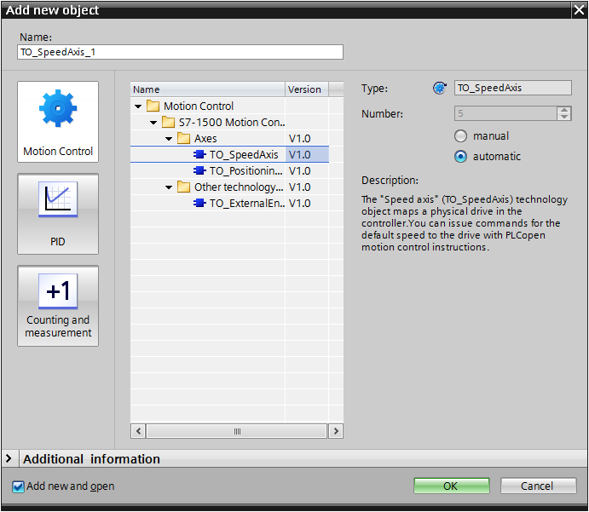

* 1. Add a drive as a Speed Technology Object and control it from the PLC

**Description**

The SINAMICS G120 Drive can be controlled from the PLC Program via the use of PLCopen blocks if added as a technology object.

The goal is to create a Speed Axis Technology Object, then provide control via PLCopen blocks in the program.

In this exercise, a Speed Axis will be added to control the PLC, and program edits will be made to allow control via PLCopen blocks.

**Objectives**

Upon completion of this exercise, the student shall be able to:

* Add a Speed Axis to the 1500 PLC.
* Configure the Axis
* Control the Axis using PLCopen blocks.

**Prerequisites**

The following prerequisites must be completed before this exercise is started:

* Exercise 5.3 has been completed.
  + 1. Configure Drive Motion Object

|  |
| --- |
| 1. Configure drive as motion object by using the motion control wizard 2. From the Project tree, expand the Drive_1 branch. 3. Double click on the entry “Parameter” to open the access the offline “Commissioning” wizards.      1. From the Commissioning list, select “Drive connected to a SIMATIC motion control axis”, as the drive ramp and speed settings will all come from the SIMATIC S7-1500 PLC. 2. Once the wizard launches, the first step is to define the drive setting for applied frequency to the motor. We are using an IEC motor, so select 50 Hz from the pulldown, then click “Next>>”.      1. The next step is to enter the detailed motor nameplate data. Enter the following parameters from the attached motor in the dialog, then click “Next >>”:   Motor Configuration: **Enter Motor Data** Select motor type: **[1] Induction motor** Connection type: **Delta**  **Motor Data**  Rated Motor Voltage: **230 V** Rated Motor Current: **0.73 A** Rated Motor Power: **0.12 kW** Rated Motor Power Factor: **0.740** Rated Motor Frequency **50.00 Hz** Rated Motor Speed: **1350.0 rpm** Motor Cooling Type: **[0] Non-ventilated**     1. In the Motion control configuration dialog, define the telegram type used for communication between the PLC and the G120 drive as **[1] Standard telegram 1, PZD 2/2** as well as the reference speed of **3000.**0 to define the reference used for motion commands generated by the PLC, then click “Next >>”:      1. The final step is to review the settings in the Summary dialog. After review, click the “Finish” button:      1. Associate the new G120 with the S7-1500 Profinet IO network and the IO controller. 2. Download new configuration to drive 3. From the toolbar, select the Download  button. The “Extended download to device” dialog will appear since this is the first download to the Drive. 4. Set the download settings as shown in the slide, then click “Start search”.      1. Select the Drive from the list of devices, then click “Load:      1. The “Load preview” dialog will appear. Make sure the **“Save the parameterization in the EEPROM”** option is checked, then click “Load”.      1. After a few moments, the download will complete without errors. If this is not the case, notify your instructor. 2. Associate the new G120 with the S7-1500 Profinet IO network and the IO controller.   (continued on next page)   1. Add a Speed Axis Technology Object to the 1500. 2. In the Project tree, expand the branch under PLC_1 labeled “Technology objects”. 3. Double-click on “Add new object” to open the “Add new object” dialog. 4. Select the “Motion Control” button. From the list of objects, expand the “Motion Control”, “S7-1500 Motion Control”, TO_SpeedAxis”.      1. Accept the default axis name. Leave the “Add new and open” checked, and click OK. |

|  |
| --- |
| 1. Next is to configure the drive hardware and software details in the PLC. In the work area, expand the branch “Hardware interface”. Select “Drive type” as **“PROFIdrive”.** In the “Drive” field, click the ellipsis button. 2. Browse to the Drive_1 element on the left hand pane and select Drive_1 from the right hand pane. Click the “check” button when complete.      1. The PLC controlled speed axis drive configuration is now complete:      1. Download the changes to the S7-1500 |

* + 1. Modify the program and add PLCopen blocks to control the TO

|  |
| --- |
| 1. Modify the program and add PLCopen blocks. 2. From the Project tree, double click on the “Add new block” object. 3. When the Add new block dialog appears, select “Function block”. Assign the name “FB_Motion” and click “OK”.      1. Enter the following block parameters in the block interface area:   **STAT Variables:** Motor Enable **BOOL** Midline Coil **BOOL** ONS_1 **BOOL** ONS_2 **BOOL**  **TEMP Variables:** SCALE_RET_VAL **INT** SCALE_OUT **REAL CONSTANTS** SCALE_HI_LIM **REAL**, default value = 1350.0 SCALE_Unipolar **BOOL**, default value = FALSE SCALE_LOW_LIM **REAL**, default value = 0.0   1. Add a SCALE instruction to Network 1 and parametrize as follows:      1. Add the following logic to Network 2 to provide a start/stop control command for the drive:      1. From the Task cards, Access the “Technology” instructions. 2. Add a “MC_POWER” block to network 3, choosing the Call option “Multi instance” and accepting the default name.      1. Parameterize the block as shown. Pay attention to the Stop Mode value of 2. **TIP-** drag and drop the TO from the project tree to the “Axis” input of the block.      1. Add the “MC_RESET” instruction to the next network. Create as a Multi instance, accept the default name, and parameterize as shown.      1. Add the “MC_MOVEVELOCITY” instruction to the next network. Create as Multi instance and parameterize as shown below.      1. Add the “MC_MOVEJOG” to the next network. Create as Multi instance and parameterize as shown below.      1. Open the Main [OB1] block for editing. 2. In the Main block call the new “FB Motion” block.      1. Download your program changes to the PLC. 2. Test the operation of the drive. Note that when you change speeds, you MUST press SW1 on the KP8 to get the speed change sent to the drive. Also, you must enable the axis before jogging.   *This completes Exercise 5.4.* |